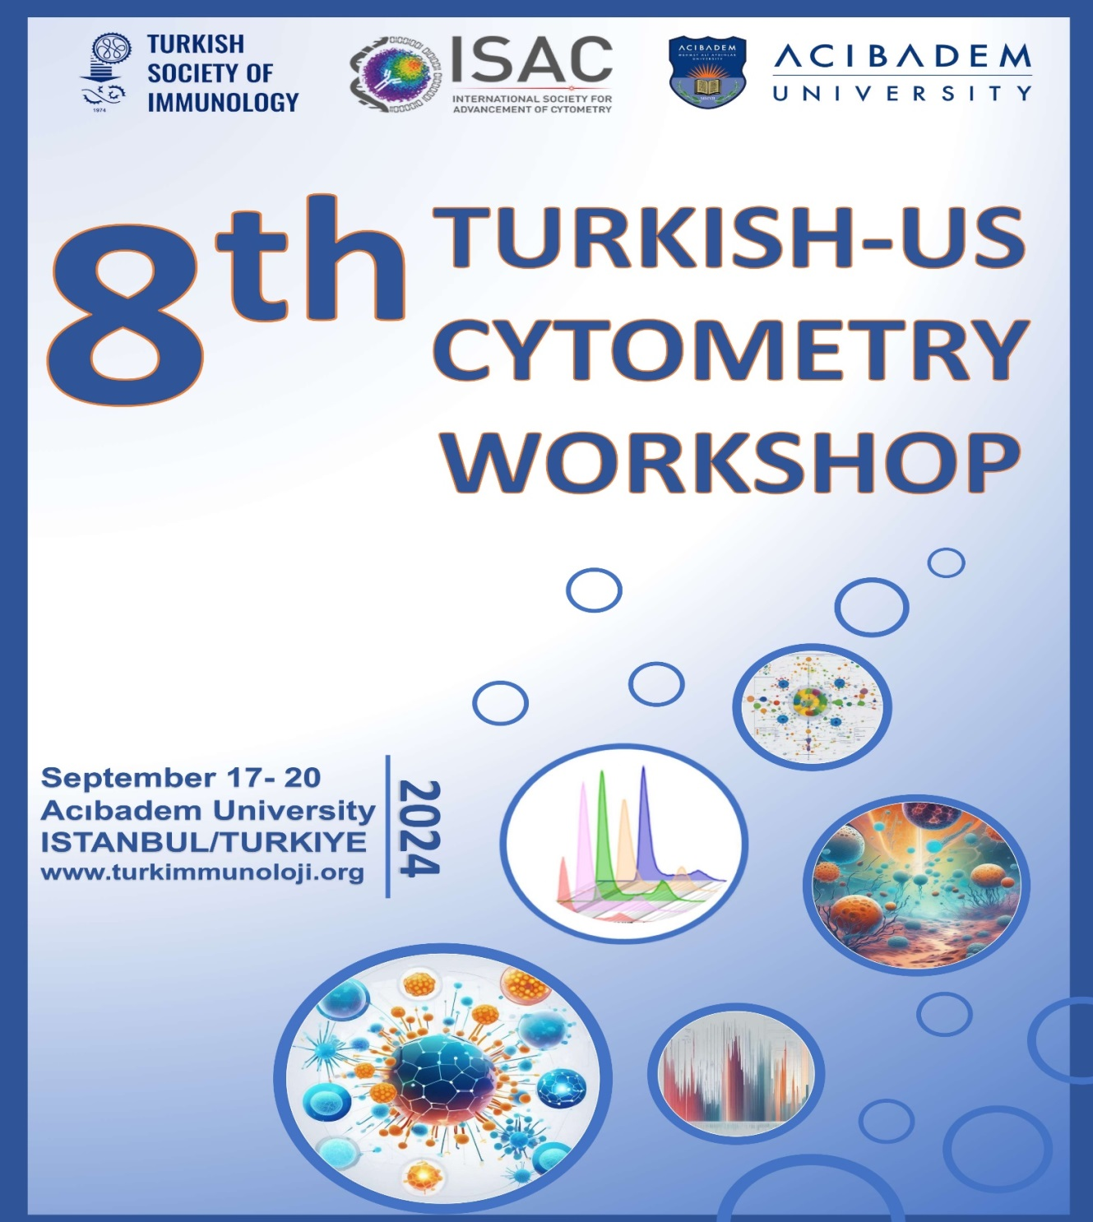

**8th Turkish-US Cytometry Workshop**

The 8th Turkish-US Cytometry Workshop, organized by the Turkish Society of Immunology, was held between September 17-20, 2024, at Acıbadem Mehmet Ali Aydınlar University in Istanbul. The scientific program of the workshop was prepared jointly by the Flow Cytometry Working Group of Turkish Society of Immunology and the Live Education Delivery Sub-Committee of the International Society for Advancement of Cytometry (ISAC). A total of 83 participants, including 49 women and 34 men, from all across Turkey attended the workshop.

giyim, kişi, şahıs, iç mekan, kadın içeren bir resim

Açıklama otomatik olarak oluşturuldu

The workshop began with opening speeches by Acıbadem University's Vice Rector, **Prof. Dr. Güldal Süyen**; President of the Turkish Society of Immunology, **Prof. Dr. İhsan Gürsel**; ISAC Education Committee and ISAC Live Education Delivery Task Force representatives **Zosia Maciorowski** and **Prof. Dr. Günnur Deniz**.

giyim, iç mekan, kişi, şahıs, duvar içeren bir resim

Açıklama otomatik olarak oluşturuldugiyim, iç mekan, duvar, kişi, şahıs içeren bir resim

Açıklama otomatik olarak oluşturuldu

On the first day of the workshop, the basic working principles and application areas of flow cytometry technology were introduced. The morning sessions covered topics such as multicolor panel design, quality control and standardization, while the afternoon sessions focused on experimental design, data analysis, and the analysis of extracellular vesicles using flow cytometry.

iç mekan, mobilya, kurs, yol, eğitim içeren bir resim

Açıklama otomatik olarak oluşturulduiç mekan, duvar, giyim, kişi, şahıs içeren bir resim

Açıklama otomatik olarak oluşturuldu

On the second day of the workshop, laboratory sessions included sample preparation and phenotyping, as well as extracellular vesicle analysis, spectral flow cytometry, and imaging flow cytometry applications. Using instruments such as the Becton Dickinson FACS Canto II, Beckman Coulter Cytoflex, Cytek Aurora, and Amnis Flowsight, the participants had the opportunity to experience a wide range of experiments, from simple phenotyping to multicolor panels and imaging flow cytometry.

giyim, iç mekan, kişi, şahıs, duvar içeren bir resim

Açıklama otomatik olarak oluşturulduiç mekan, kişi, şahıs, giyim, duvar içeren bir resim

Açıklama otomatik olarak oluşturuldu

On the third day of the workshop, the focus of the workshop was hematology, one of the areas where flow cytometry technology is most widely used. Recent developments in routine clinical applications and current research were shared. In this context, the use of flow cytometry in clinical diagnosis, monitoring and immunophenotyping of leukemia and lymphoma, MRD analysis in ALL, AML, and multiple myeloma, standardization of CD34 and PNH cell counting, immunophenotyping in CSF samples, and the role of flow cytometry in cellular immunotherapies were discussed.

In addition to the theoretical and practical sessions of the workshop, two satellite symposia were held: "*FLEXible Flow Solutions: Analysis and Sorting of Cells and Everything Smaller than Cells*" organized by Beckman Coulter, and "*InfinicytTM Tools and Strategies for the Analysis of MRD Files*" organized by Becton Dickinson.

On the final day of the workshop, detailed sessions on imaging flow cytometry technology and flow cytometry data analysis were conducted. The closing lecture was delivered by one of the world's leading researchers in flow cytometry, Paul Wallace (Roswell Park Comprehensive Cancer Center), with a talk titled "Tracking a Lifetime of *Adventures in Flow Cytometry while Fostering Everlasting Friendships*".

The program included a total of 20 talks, featuring ten theoretical sessions and five hands-on laboratory trainings. The theoretical lessons and laboratory sessions were led by prominent experts from Turkey and around the world, including **Arzu Aral** (Yeditepe University Faculty of Medicine, Department of Immunology), **Barbaros Oral** (Uludağ University Faculty of Medicine, Department of Immunology), **Tolga Sütlü** (Acıbadem University Faculty of Engineering and Natural Sciences, Department of Molecular Biology and Genetics), **Günnur Deniz** (Istanbul University, Aziz Sancar Institute of Experimental Medicine, Department of Immunology), **Esin Çetin Aktaş** (Istanbul University, Aziz Sancar Institute of Experimental Medicine, Department of Immunology), **Güher Saruhan Direskeneli** (Istanbul University Faculty of Medicine, Department of Physiology), **İhsan Gürsel** (Izmir Biomedicine and Genome Center), **İlknur Kozanoğlu** (Acıbadem Labmed Clinical Laboratories), **John Nolan** (Scintillon Research Institute), **Klara Dalva** (Ankara University Faculty of Medicine, Department of Hematology), **Maria Arroz** (HEM and HSFX Flow Cytometry Laboratories, Lisbon), Maria James (Cytek Biosciences, USA), **Batu Erman** (Acıbadem University Faculty of Engineering and Natural Sciences, Department of Molecular Biology and Genetics), **Owen Hughes** (Cytek Biosciences, USA), **Paul Wallace** (Roswell Park Comprehensive Cancer Center, USA), **Raif Yücel** (University of Exeter, UK), and **Zosia Maciorowski** (ISAC Live Education Delivery Subcommittee, France).

We would like to thank Beckman Coulter, Becton Dickinson, Cytek, Sysmex, Genera, Medtech, Labgen, Invitro-lab, and D-event Tourism Organization for their contributions to the success of the course.

giyim, kişi, şahıs, ayakkabı, iç mekan içeren bir resim

Açıklama otomatik olarak oluşturuldu

"***Many thanks to everyone who participated in and contributed to the 8th Turkish-US Cytometry Workshop***."

metin, logo, yazı tipi, ekran görüntüsü içeren bir resim

Açıklama otomatik olarak oluşturuldugrafik, grafik tasarım, metin, ekran görüntüsü içeren bir resim

Açıklama otomatik olarak oluşturulduyazı tipi, metin, grafik, logo içeren bir resim

Açıklama otomatik olarak oluşturuldu